

Project Interim Report

On

Contact Directory Management System

(Using Core Java & OOP Concepts)
RU-100-01-00012
Object Oriented Programming with Java

SESSION: 2025-26

Submitted By Ankit kumar
ERP-ID: RU-25-10211

Bachelor of Technology in Computer Science & Engineering with AI and ML in association with IBM

Under the Guidance of Mr. Santanu Sasmal IBM SME and EXPERT

SCHOOL OF COMPUTER SCIENCE AND ENGINEERING RUNGTA INTERNATIONAL SKILLS UNIVERSITY
BHILAI, CG

(April 2026)

Abstract
The Contact Directory Management System is a Java-based project developed using Object-Oriented Programming (OOP) concepts. The main aim of this project is to store and manage contact details like name and phone number in an efficient way.
This system helps reduce manual effort and provides an easy way to add, search, delete, and display contacts. It uses a Contact class to store individual contact details and a Directory class to manage multiple contacts using an array.
The project demonstrates important OOP concepts such as encapsulation, class design, and data management. It also uses simple searching techniques like case-insensitive comparison to improve usability.
Overall, this system is simple, user-friendly, and can be extended in the future with database and GUI features.

Introduction
The Contact Directory Management System is developed using Java and Object-Oriented Programming (OOP) concepts. It is designed to manage contact details in a simple and efficient way.
Key Points:
- The system stores contact details such as name and phone number
- It uses OOP concepts like classes and objects for better structure
- The Contact class represents individual contact entries
- The Directory class manages multiple contacts using an array
Features of the System:
- Add new contacts
- Search contacts by name
- Delete existing contacts
- Display all stored contacts
- Case-insensitive search for better usability
Objectives of the Project:
- To manage contact records efficiently
- To reduce manual work
- To implement OOP concepts in a real-world application
- To understand array handling and data management

Scope
The scope of the Contact Directory Management System is limited to basic contact management using Java.

Key Points:
- Suitable for personal use or small-scale applications
- Can store and manage a limited number of contacts using arrays
- Provides basic operations like add, search, delete, and display
- Useful for understanding real-world implementation of OOP concepts
Future Scope:
- Can be extended using database integration (MySQL)
- Can include better Graphical User Interface (GUI)
- Can support large-scale data storage
- Additional features like sorting and contact grouping can be added

System Requirements
The system requirements for the Contact Directory Management System are as follows:
Hardware Requirements:
- Computer or Laptop
- Minimum 4GB RAM
- Basic keyboard and display
Software Requirements:
- Java Development Kit (JDK)
- IDE (VS Code / Editplu / IntelliJ IDEA)
- Operating System: Windows, Linux, or macOS

Methodology
The methodology of the Contact Directory Management System is based on a menu-driven approach. The system performs different operations based on user input.
Working Steps:
- The program starts and displays a menu with available options
- The user selects an operation (Add, Search, Delete, Display)
- Add Contact:
  - User enters name and phone number
  - A new contact object is created
  - It is stored in the array
- Search Contact:
  - User enters the name to search
  - The system compares names using case-insensitive method
  - If found, contact details are displayed
  - Otherwise, "Contact not found" is shown
- Delete Contact:
  - The system searches for the contact
  - If found, it removes the contact
  - Remaining elements are shifted to maintain array order
- Display Contacts:
  - All stored contacts are displayed one by one
- The program continues until the user chooses to exit

Flowchart

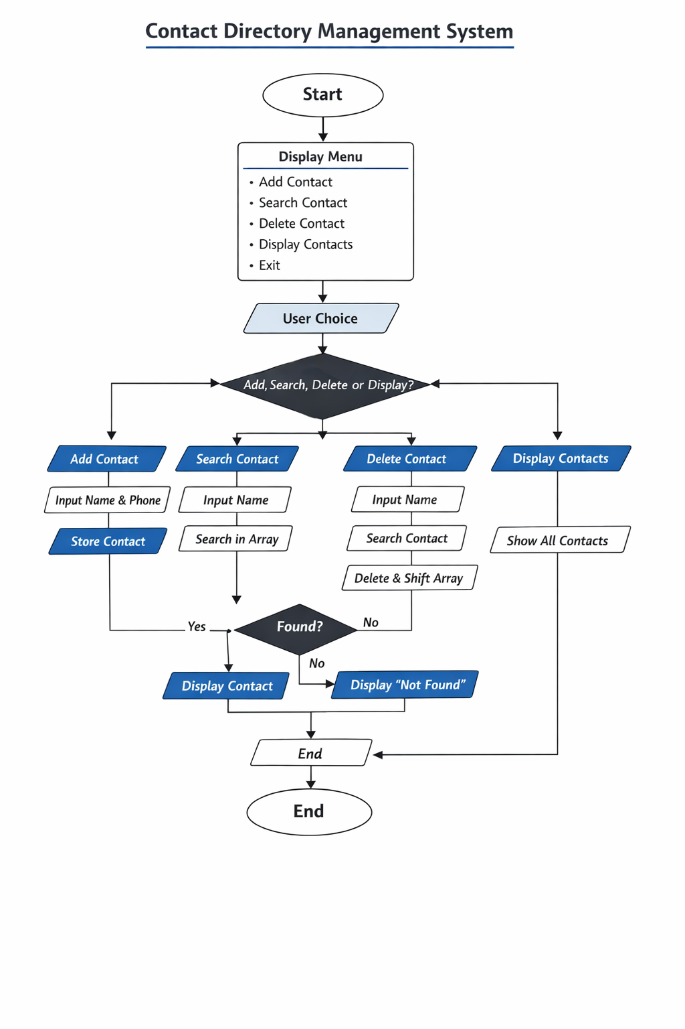

Implementation

The Contact Directory Management System is implemented using Java and follows Object-Oriented Programming (OOP) principles. The program is divided into two main classes: Contact and Directory.

Contact Class:

This class is used to store individual contact details

It contains two variables: name and phone number

A constructor is used to initialize these values

Getter methods are used to access the data

Directory Class:

This class manages multiple contacts using an array

It contains an array of Contact objects and a counter variable to track the number of contacts

Methods Used:

addContact():

Adds a new contact to the array

Checks if there is space before adding

Stores the contact at the next available position

searchContact():

Searches for a contact by name

Uses case-insensitive comparison

Displays contact details if found

Otherwise shows "Contact not found"

deleteContact():

Searches for the contact to delete

Removes the contact if found

Shifts remaining elements to maintain array structure

displayContacts():

Displays all stored contacts one by one

Main Method:

Creates an object of Directory class

Calls different methods based on user input

Demonstrates all operations like add, search, delete, and display

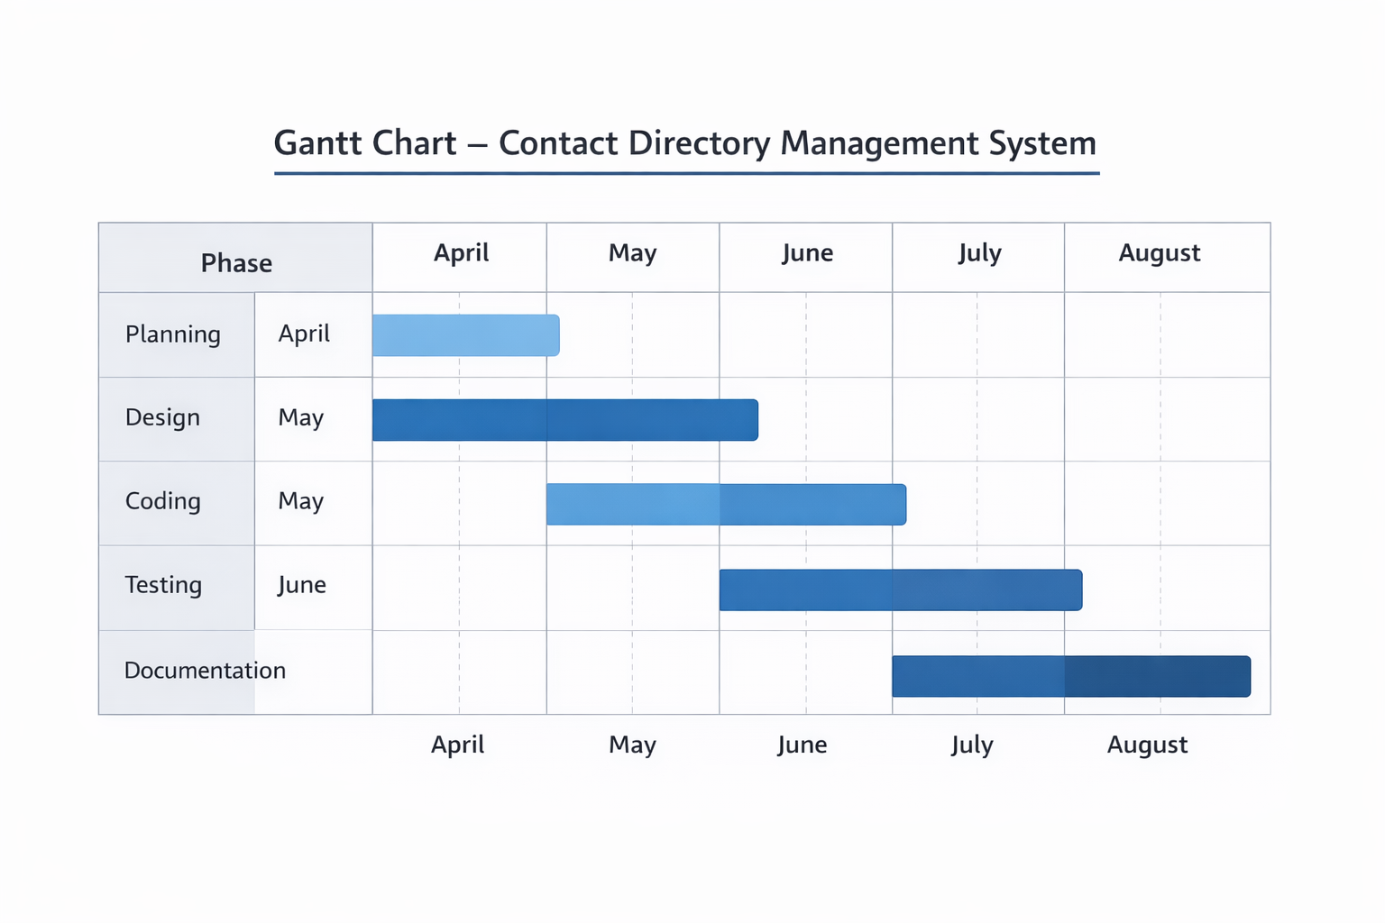
Gantt Chart

Explanation:
- Planning phase includes understanding project requirements
- Design phase includes creating class diagram and flowchart
- Coding phase involves writing and implementing the program
- Testing phase ensures error-free execution
- Documentation phase includes preparing the final report

Conclusion
The Contact Directory Management System successfully demonstrates the implementation of Object-Oriented Programming (OOP) concepts using Java. The project provides a simple and efficient way to manage contact details through operations like adding, searching, deleting, and displaying records.
Through this project, important concepts such as class design, encapsulation, array handling, and searching techniques are clearly understood. The system is user-friendly and helps in reducing manual effort in managing contacts.
Overall, the project serves as a practical example of applying programming concepts to solve real-world problems. It can be further enhanced by adding features like database integration and graphical user interface for better usability.

Reference

